**Mission Report**

**From 4-8 November 2019**

**Objective**

* **Investigate the accessibility and availability of Forecast, hydrological observations, Vulnerability, and Disaster data for InaSAFE**
* **Develop towards trigger model**

**Findings**

* Deltares develop calibrated flood model (flood depth map) for three river and Wflow (hydrological model-discharge) for whole country – data and system are ready but not calibrated. They agree to share but through Ministry of Public Works or JCP which may take time. These are the model produce flood depth map we need. Not have enough time explore for InaSAFE. But worth to try for the final version.
* Signature product – flood alert – simple and good tool but not ground verification. It is not hydrological model but use 24HR cumulative rainfall forecast from ECMWF and flood hazard index. The lead time 3dys. Good to have indication about the flood and also location for our trigger. Must also have access need MOU which will take months.
* GLOFAS is a global hydrological flood forecasting model works for large basin (flow over 1000m3/s) and also produce flood depth map. River basins in Indonesia not calibrated and GLOFAS team interest to participate with InaSAFE to calibrate. GLOFAS forecast flood return period.
* Field visit and observations shows impact limit may consider when water reaches road level + half meter (need to be validated). And the level represents 1 in 10 year or more.

Recommendations

Two stage trigger

1. Pre-activation trigger to get ready with resource in the chapter using GLOFAS. Activation Hazard criteria are
   1. Hazard > 10 year return period
   2. 50% or more Probability
   3. Lead time minimum 10 days
   4. 20% more house likely to be damage

Procedure

When GLOFAS forecast flood 1 in 10 year return period with 50% more chances, use global ECMWF flood depth map with 10 year return period. The flood depth map will be used to estimate the house damage. If damage crosses the limit 20%, pre activation call reaches to activate readiness.

1. Activation trigger to activate EAP – evacuation
   1. Hazard > 10 year return period
   2. 70% or more Probability
   3. Lead time minimum 3 days
   4. 20% more house likely to be damage
   5. BMKG Signature also shows high likelihood and high impact

Process

GLOFAS forecast flood 1 in 10 year return period with 70% more Chances. Area of intervention are same as identify in the pre activation trigger. Check with Signature high impact area.

Step 1

Monitor GLOFAS forecast of a critical station for the basin (Figure 1)

Step 2

If forecast show 50% more chance to cross 1 in 10 year return period

Step 3

Open 1 in 10 return period flood depth map for thebasin will be exposed to flood (Figure 2)

Step 4a HH

Calculate the impact based on flood return period- pre activation score 7 or mire and >20% Impact andn activation wnen score 9 or more.

|  |  |  |  |  |  |  |  |
| --- | --- | --- | --- | --- | --- | --- | --- |
|  |  |  |  |  |  |  |  |
|  |  |  |  |  |  |  |  |
|  |  |  |  |  |  |  |  |
| Likelihood | High | >70 |  |  | 8 | 9 | 10 |
| Moderate | 50-70 |  |  | 7 | 7 | 8 |
| low | <50 |  |  |  |  |  |
|  |  |  | 2 | 5 | 1o | 50 | 100 |
|  |  |  |  |  |  |  |  |
| Impact | VS | 60 |  |  |  |  | x |
| S | 40 |  |  |  | x |  |
| M | 20 |  |  | x |  |  |
| L | 10 |  | x |  |  |  |
| N | 0 | x |  |  |  |  |
|  |  |  | 2 | 5 | 1o | 50 | 100 |
|  |  |  |  | Return Period | | |  |

Step 4b

Calculate the impact based return period to flood depth map (figure 2)

**From depth to impact**

**Step 5**

Intervention location– pixel / area cross impact limit and prioritize based vulnerability index score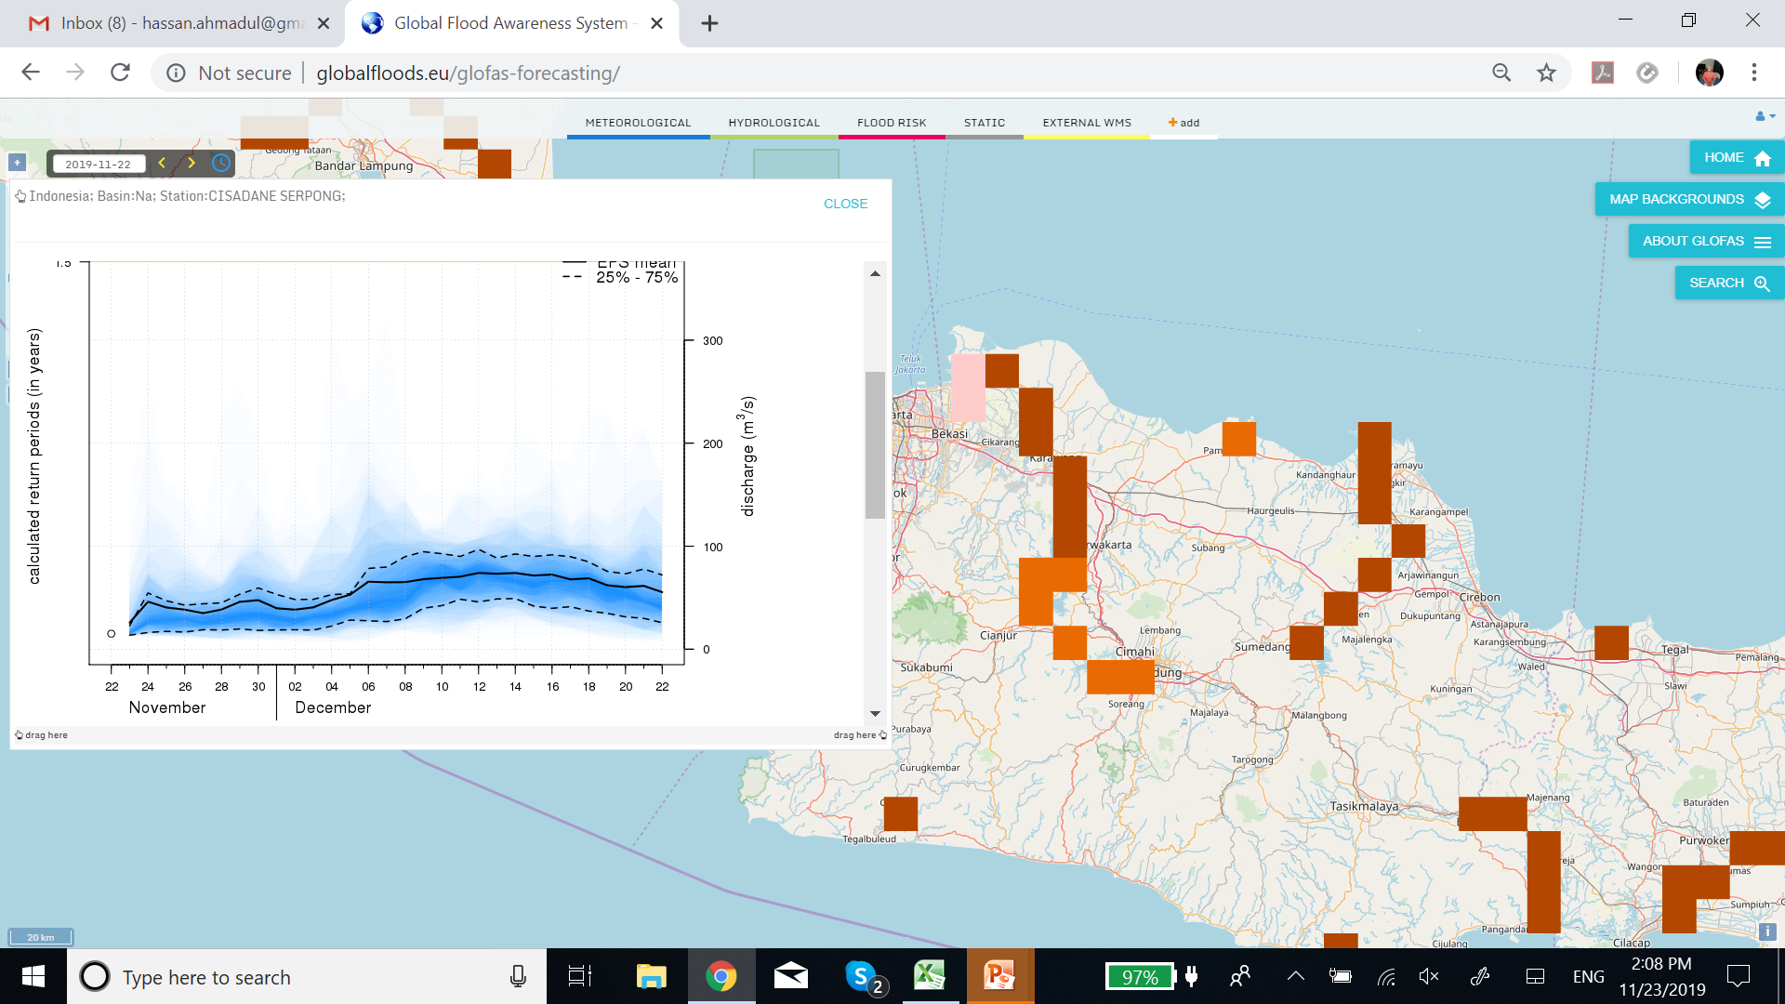

**Figure 1L GLOFAS model result**

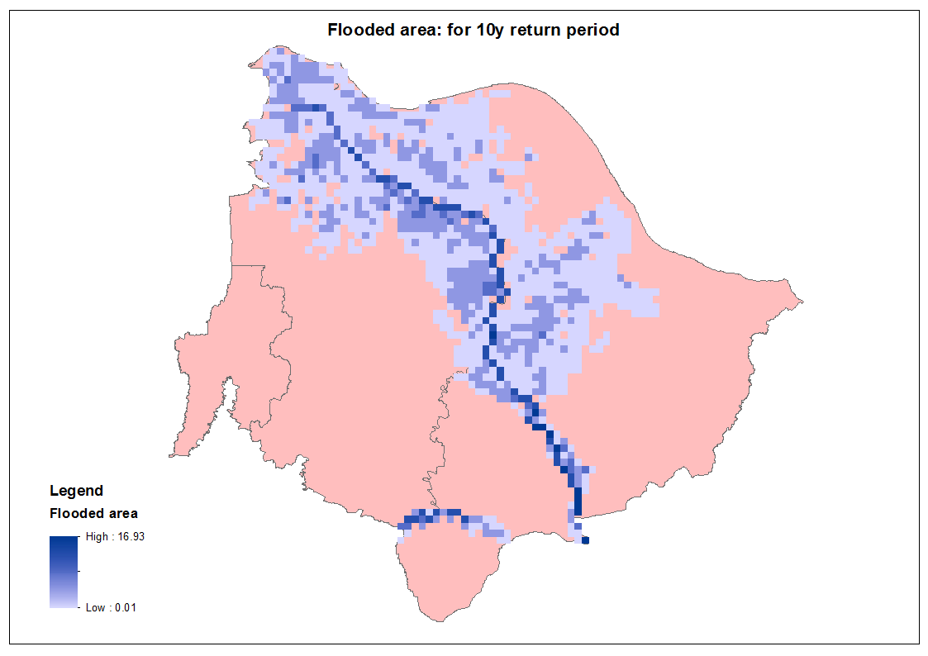

**Figure 2: Flood depth**

**Plan**

Final deliverable operational Trigger tool for flood by April 2020

December will be first alpha version with the model running

Between December April, tuning/refinement of the model and hand over to PMI/Stakeholders

From now to December,

# Forecast

1. Accessibility, data format, API access, service endpoints of (Signature), from BMKG – IT department
2. Model (Hydrology and Hydrodynamic model) used for Flood Forecast in Multi Hazard Early Warning System by BNPB – IT department
3. Collect the historical hindcast from 2013 – 2018 Flood warning data from Signature tools
4. Find any 3 to 5 big flood events year and damage from BNPB
5. Investigate how we can have model results and data access (API) from FEWS Deltares
6. Investigate how we can have model results and data access (API) from WFLOW model Deltares
7. Include GLOFAS data point for Indonesia
8. Check historic 10 GLOFAS forecast –and assess skill

# Observations/Monitoring Data

1. Spatial locations of water level and discharge stations in the country (we already collect 2 provinces, need remaining locations)
2. Identify key strategic locations for GloFAS flood forecast
3. Collect flood depth map for different return periods (at least 1 in 10 year) –global data set, Deltares JFEWS and observed flood extent
4. Effort to collect the hind cast model rest from of Signature, WFLOW and FEWS
5. Flood extent (the area) from Satellite Imagery or from field information (it could be from LAPAN), by capturing SAR of certain date where certain region is flooded in the past

# Model

1. Get GloFAS data and validate
2. Provide forecast points (station points) to GloFAS
3. Compute return period based on observation data with GloFAS
4. Validate the flood depth mas with ground information

# Hazard vs Impact

1. Damage information collected within two districts (Karawang – Bekasi) relate it with water discharge or area of flooding
2. Estimate return period for 3 key strategic locations of nodal points of GloFAS, or 5 station points in that basin
3. Field observation and damage data

# Discharge to Flood Depth map

1. From the discharge model (GloFAS, or WFLOW, or FEWS), relate discharge with return period
2. From return period relate with depth from embankment so we can have flood depth hazard map (by filling elevation map with the same depth)
3. From hazard map get impact map by overlaying it with exposure

# Organizational/Institutional Activity

1. Update MoU if needed (between BNPB, PMI, and BMKG) for signature output access data (API)
2. Update MoU if needed for Ministry of Public Works/Deltares, under JCP (Joint Cooperation Program) to have access data (API) for model output
3. Deltares FEWS and WFLOW model data through Ministry of Public Works or JCP which need to follow up.
4. Arrangement with GLFOFAS data access and calibration

**Visit note**

**Day 1 note: 4th November, 2019**

1) Discuss on with Raja on the Meetings schedule - BMKG, BMPB, Deltares and field trip – and if possible meeting with IFRC/ Australian RC.

2) Meeting start at 2pm with PMI Teguh and IT/database experts and Mr. Atik from IFRC

3) Raja informed us that the objectives of the PMI intervention for FbA are safe life, safe livestock and protect/reduce the asset damage. To achieve the objectives, PMI like to take early actions that are evacuation and support with resource.

4) Parmin - PMI/IT expert present the database and the capacity assessment framework and explain the criteria and indicators (it was in Indonesia language - Rizky will collect and translate for me)

The capacity assesses in-terms of livelihood asset –human, social, natural, physical and financial capital. There are 88(?) Indicators (Rizky will collect). The initiative supported by IFRC but for the villages in a district. Question is how we assess the capacity of the chapter for evacuation as readiness for FbA. EAP team of FbA needs to define and assess the capacity for the chapters exposed to flood.

PMI/IT team informed that the OSM for three cities Jakarta, Surabaya, Semarang are built under the program called HOT.

5) Rizky informed the participant from PMI that InaSAFE use the global data /OSM as proxy for the vulnerability assessment. Finally, discus on the process, progress and importance of quality data. I explain there are three key elements in FbA - Forecast - Vulnerably - Chapter capacity. InaSAFE will build the trigger model using impact forecast and vulnerability.

6) Rizky provide 5 stations observed data on water level ad discharge

**Day 2 note: 5th November, 2019**

Team meeting with Raja and Rizky at IFRC

Discuss about the strategy for tomorrow BMPB meeting.

Team agree following area need to be cover in the presentation

* FbA concept
* Institute engagement
* InaSAFE - automation the process of trigger
* Forecast to trigger use impact limits/ thresholds
* Importance of use signature – flood alert showing impact with likelihood for InaSAFE and the access to product. Aarea showing color code based on impact matrix

Decide on the needs for InaSAFE

A) Access to signature

B) Hind-cast of signature from 2013-2019 for two districts - to develop thresholds

C) Explore the process that used in Signature to translate the Rain fall forecast (intensity and probability from ECMWF) to the impact matrix.

In our team discussion following question raised

* Is BMPB having access to (api) signature product including inputs (rainfall, inarisk hazard index etc.)?
* If yes no need of MoU between BMPB and BMKG for access to signature data – As InaSAFE is a BMPB’s project we can get directly from them.
* If not need MOU

**Field visit**

With Rizky and Atik visit the West Karawang, Cibeet River.

* In 2010 the flood height is at least 0.5 to 1.5 meter on the top of the roads.
* Visit evacuation centre made by Zurich Flood Resilience project – capacity 1200?
* Elevation difference between River bank and road level varies 1- 2 meter.
* The agriculture field are 1 meter bellow road level and villages are at road level

In the evening – skype meeting with GLOFAS team, Climate Centre and kartoza Team

* Talk on cooperation and access to the global flood model
* Both party interested to support InaSAFE
* Discussion and decision are summarized in annex

**Day 3 note: 6th November, 2019**

Prepare the presentation for BMPB meeting (annex) and meeting start with BMPB after launch.

Meeting start at 13.30 chai by Pak Bambang   
Raja start - briefing BMPB professionals on FbA and InaSAFE  - long discussion in Indonesia language- difficult for me to follow.  
I give short introduction about the FbA and InaSafe link and who are the key stakeholders and what cooperation we are looking for. Rizky continue the presentation - detail out the vulnerability indicators etc. - question raised house size not represent the living condition  
BMPB also show in there permutation on MHEWS - gathering tool use the flood forecast (?) with the support from BMKG and water resource research institute.  
Also informed us BMPB has access to signature of BMKG. In the meeting also mention BMPB has own model/procedure to calculate the impact. But procedure was not explained – Rizky will visit and discuss with the professor on the procedure and flood forecast model.

BMPB show great interest on InaSAFE initiative and like to share the data. Agree to give us access to signature data but need update the MoU with PMI. Raja need to follow up with PMI.

After the meeting with BMPB, I discuss with our team and raise following questions need to be investigated

* do BMPB have flood model (hydrological or hydrodynamic model)? If Yes, who develop the model for which basin.

Follow up points

* Rizky need to go to Hydrology research centre – find and access to the data and model use
* Raja need to talk and follow it up with PMI and IFRC - regarding MoU with BMPB

**Day 4 note: 7th November, 2019**

Meeting with Deltares in the morning and Deltares shows Hydrology models, FEWS and the works on flood modeling in Indonesia.

Deltares develop J- FEWS for three main river basins (???) - where use hydrological and hydrodynamic SOBEK - produce flood depth map.  But use real time rainfall data, no forecast data used. Fully calibrated model and validate as shown us in the presentation.

* They also informed us there is a hydrologic model W Flow cover whole country - grid based with pixel size 500 m x 500m.  But not fully calibrated.  Where GloFAS pixel is 1000km but easy to access an operational forecasting system. We can validate the GloFAS flood depth model with J FEWS data if we have access to the flood depth map. JCP receive technical support from Pusair and needs to be followed up.
* Deltares agree to share but through Ministry of Public Works or JCP.

After Deltares meeting after launch we went to BMKG to discuss with technical professional on Signature process and product.

BMKG shows us the calculation for impact matrix support from WMO.

* Use ECMWF 3day rainfall forecast (intensity and probability).
* Use flood hazard index develop (inarisk) - fixed polygon/area. But not clear what was index value used
* high intensity of rain on high Hazard indexed area - assume  severe impacts  
  This assessment process need further clarification on hazard- intensity- impact

BMKG raise the question if the signature is given when and where to act, why InaSAFE need to develop the trigger tool.

In response – Signature use 24hr cumulative rainfall in high flood hazard index zone showing severe impact - there are other factors. Yes rainfall is the cause for flooding but without hydrological model difficult to predict. Further mode from hazard forecast to impact severity need procedure which InaSAFE will develop with support from BMKG and BMPB and also PMI. Define the impact limits depends on socio economic condition and other vulnerability factors.

To find the data format and access to Api, Rizky to visit BMKG and discuss with the relevant technical person.

Any way BMKG also need MoU for the digital data access.

After the visit - prepare an activity list need to complete by December middle and also prepare a summary presentation on our mission for the meeting with PMI (tomorrow).

﻿**Day 5 note: 8th November, 2019**

Meeting with PMI Director and the team and start at 10.30 at PMI office

Director welcome my visit and like to know mission findings, status of InaSAFE progress and what is next.

Raja gives introduction about visits and key findings and also highlights need for MoU to access the data from BMKG and BMPB.

Rizky and I do the presentation on our visit day by day (see presentation in annex).

I brief the Director about our visit to BMPB, BMKG Deltares and field trip. We informed him both BMKG and BMPB shows interest on the FbA concept and would like to support the InaSAFE. To have access to signature product need to renew the MoU between BMPB and PMI and also may need with BMKG.

We also inform, InaSAFE will use global data set and global flood forecast. The toll will be ready by end of December for trial runs and expected to have the operational final version by end of April 2020.

Final deliverable by April, 2020. Between December and April, tuning/refinement of the model and hand over to PMI/Stakeholders.

PMI also request us to provide recommendation for FbA.

Annex 1

**Meeting with GLOFAS, Kartoza and Climate Centre**

November 5, 2019

**Discussion points**

1. Kartoza Team – Tim welcome the GLOFAS team and like to know what is possible with GLOFAS model for Indonesia.

2. GLOFAS Team – Explain the products forecast the discharge with 30 days lead time and recent version includes the flood depth map (1km2 resolution). Use limitations – forecast discharge can be used where the flow of the river basin is more than 1000 m3/s and flood map use full where the basin area is over 5000 km2. In the tropical country prediction of the rainfall is difficult, hence discharges also, but higher confides in the Brahamputra basin. River basins in Indonesia not calibrated and GLOFAS team interest to participate with InaSAFE to calibrate.

3. Climate Center – introduce InaSAFE and what we need – forecast flood depth map for whole Indonesia. Ask for historical flood depth but GLOFAS say possible but need time. Agreed to work with model simulated discharge for the historic flood years.

**Follow up**

* + GLOFAS – will provide historic discharge simulation model output for 3 locations (already sent)
  + InaSAFE team will collect all the observation discharge stations locations and send to GLOFAS team to include in the model.
  + InaSAFE team also going to collect the discharge and water level data and validate against the historical discharge reforecasts. They will and share the findings with GLOFAS for further improvement.
  + GLOFAS in coming years will provide historical flood depth map 2010 - 2019 for the interested basin and compare model result with field data.
  + GLOFAS agree to support the InaSAFE with flood map forecast data and InaSAFE also agree to acknowledge the model use and sharing the observation data and the learning.
  + The flood maps are (as of today) being released on a daily basis. InaSAFE will incorporate the flood map extents from the real-time forecast into their GIS-based model to understand the locations and assets at highest risk.
  + InaSAFE team develops a prototype in Bangladesh and in Indonesia.